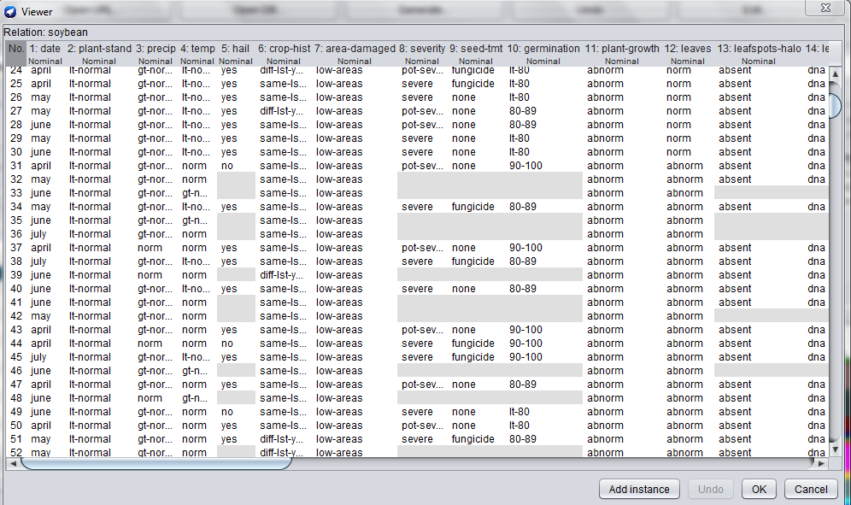

**SOYBEAN DATASET**

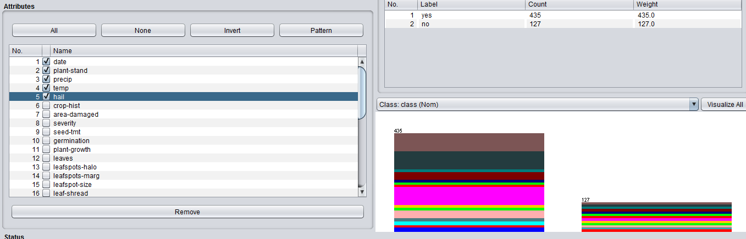

**ATTRIBUTE SELECTION**

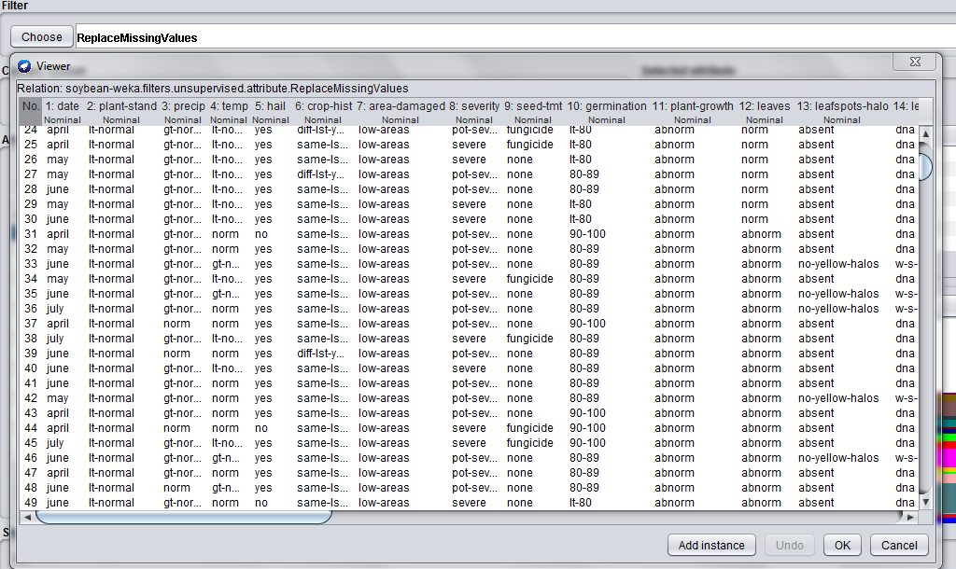

**AFTER REPLACING MISSING VALUES**

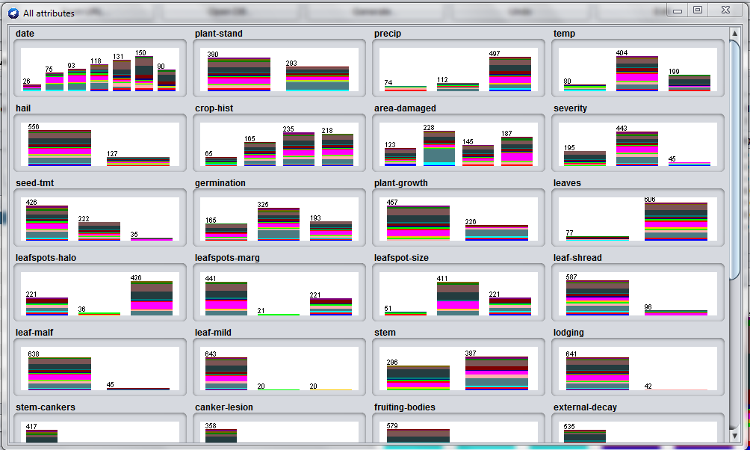

**VISUALIZATION AFTER REPLACING MISSING VALUES**

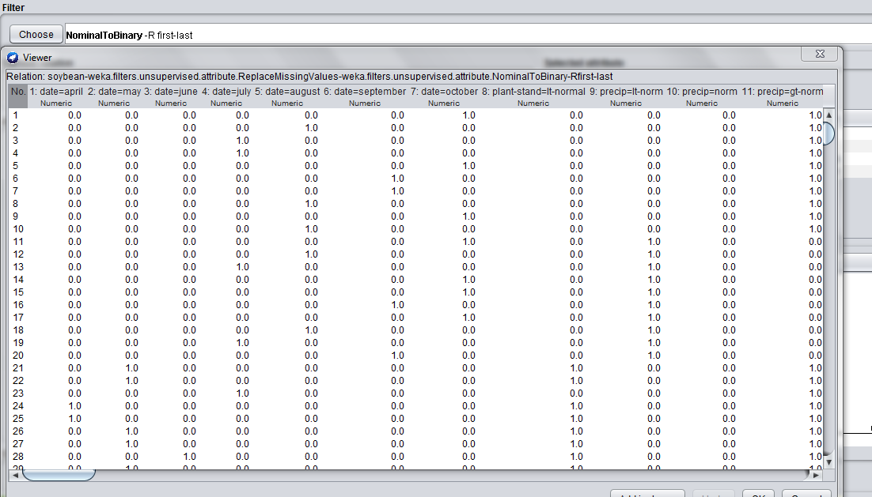

**NOMINAL TO BINARY**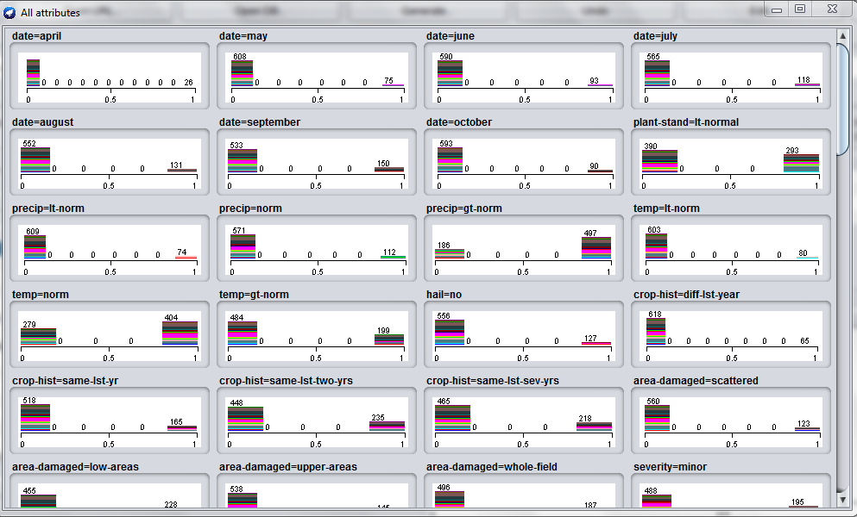

**VISUALIZATION AFTER CONVERTING FROM NOMINAL TO BINARY**

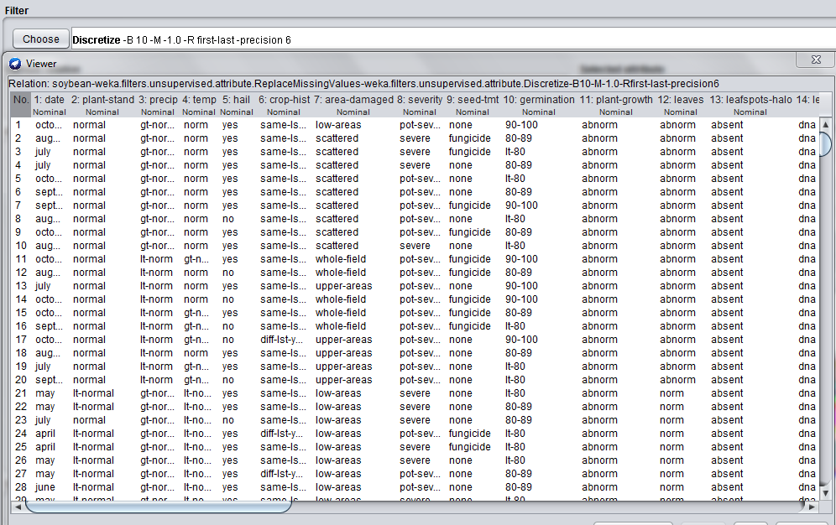

**DISCRETISATION** 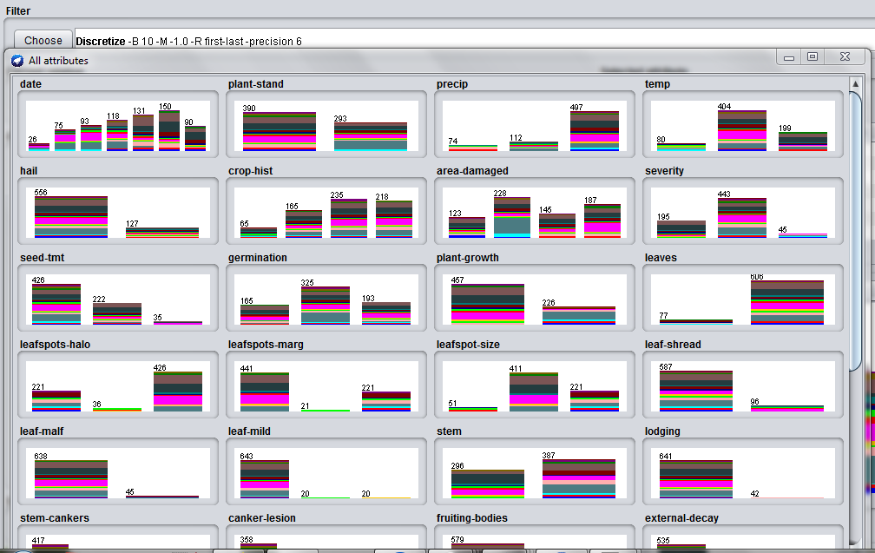

**VISUALIZATION AFTER DISCRETISATION**

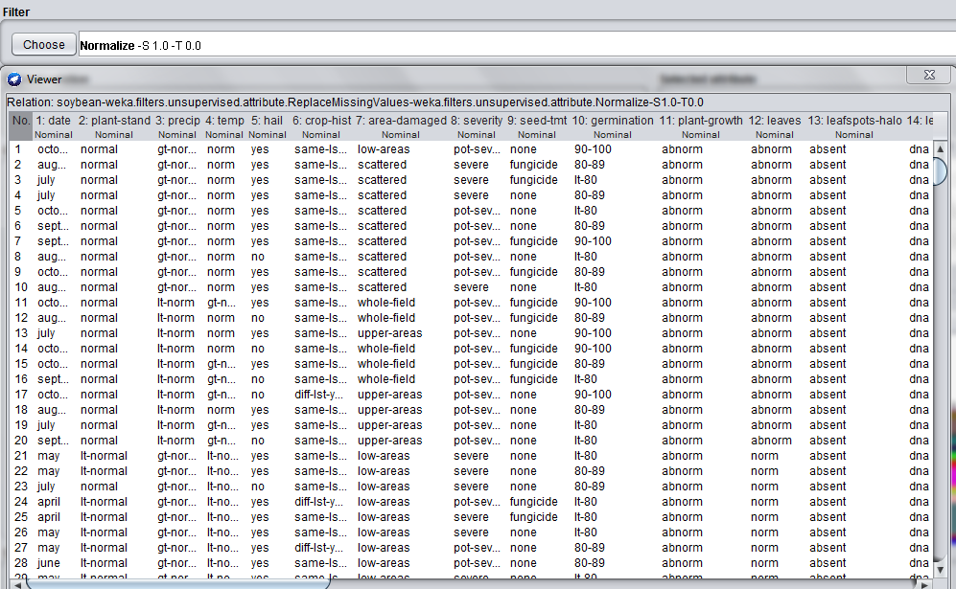

**NORMALISATION** 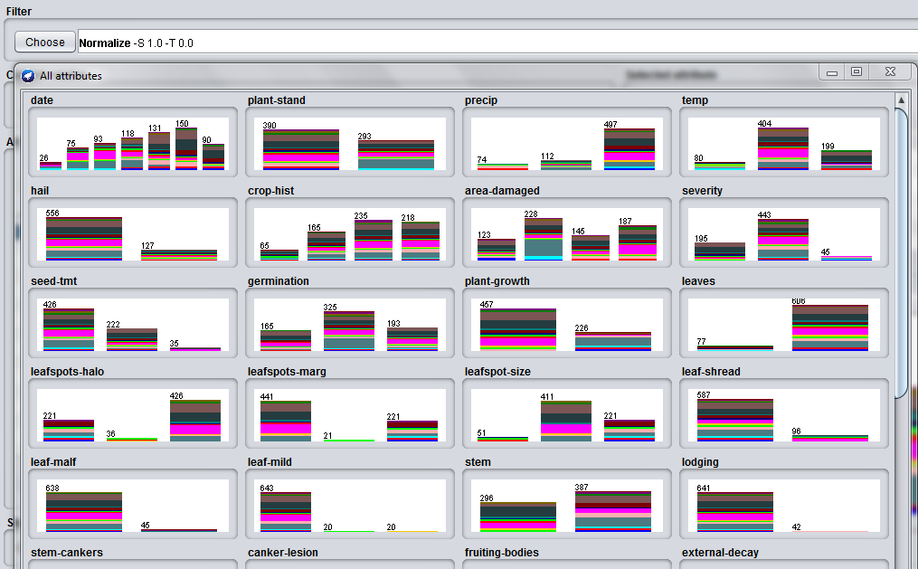

**VISUALISATION AFTER NORMALISATION**

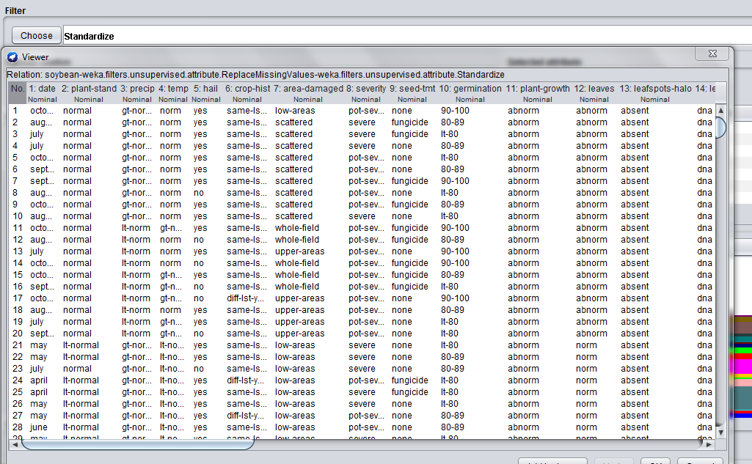

**STANDARDISATION**

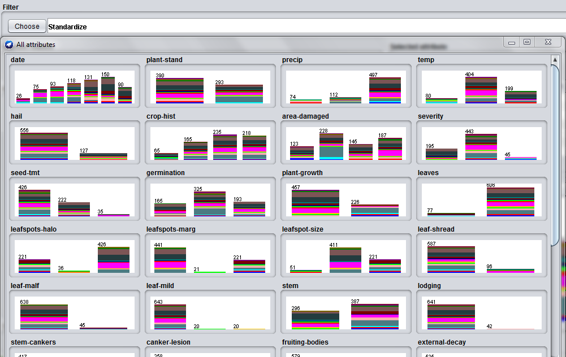

**VISAUALISATION AFTER STANDARDISATION**

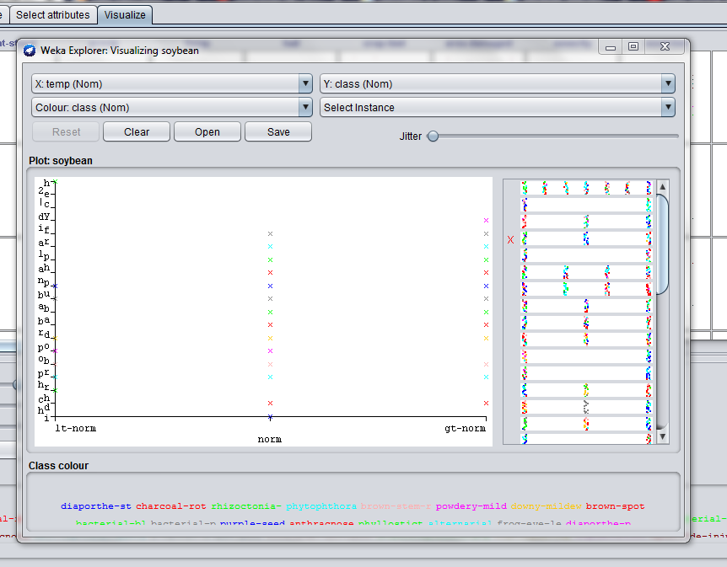

**DATA VISUALISATION** 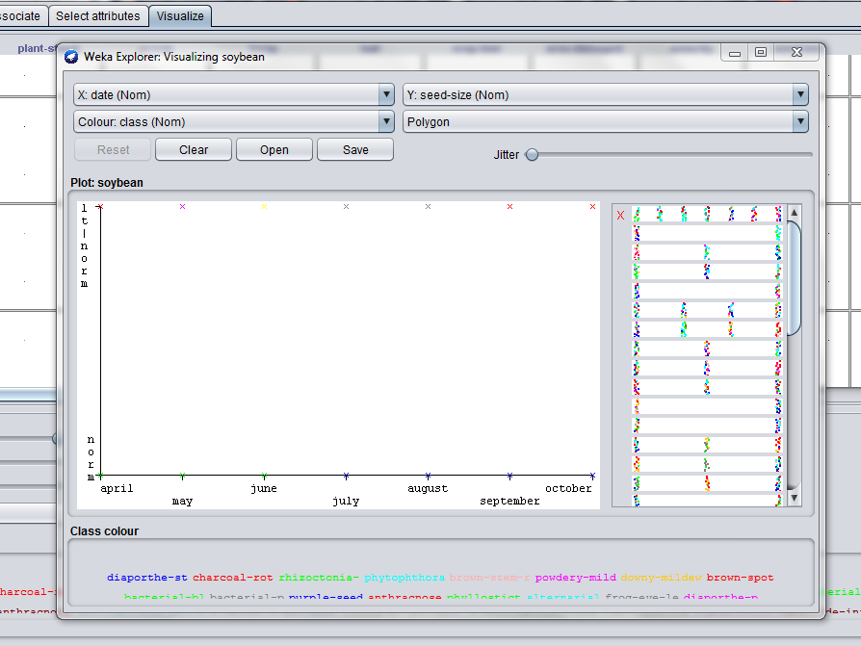

**DATA VISUALISATION**